**End of civil engineering works for Tokamak building**

[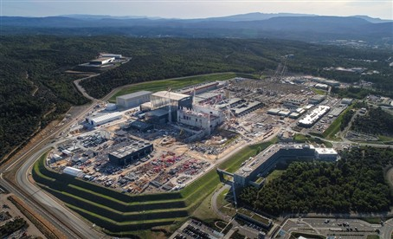](https://f4e.europa.eu/Downloads/News/drone_riche_platform-2_18110291-181120191200-Large.jpg)

Aerial view of ITER construction site, Cadarache, France, October 2019 © ITER Organization/EJF Riche

​The finish line of the civil engineering works of the main ITER building is here. It is where the biggest tokamak in history will be installed. A powerful machine that will magnetically confine a burning plasma to test the potential of fusion energy at unprecedented scale. Almost resembling to a fortress, the entire complex which includes the Tritium, Tokamak and Diagnostics buildings is 120 m long and measures 80 m high and 80 m wide. Its slab is made of 150 000 m3 of concrete and only for the Tokamak building 19 000 t of reinforcement rebars have been used.

Above this edifice which stands firmly on the ground overlooking the 42-hectare ITER site, two heavy crawler cranes are lifting beams to create its 2000 t rooftop structure which will form an extension of the Assembly Hall, where the components will be put together and subsequently will be transported so as to be installed in the machine. Meanwhile, the second and third floors of the Tokamak building have been painted leading the way to the finishing touches required.

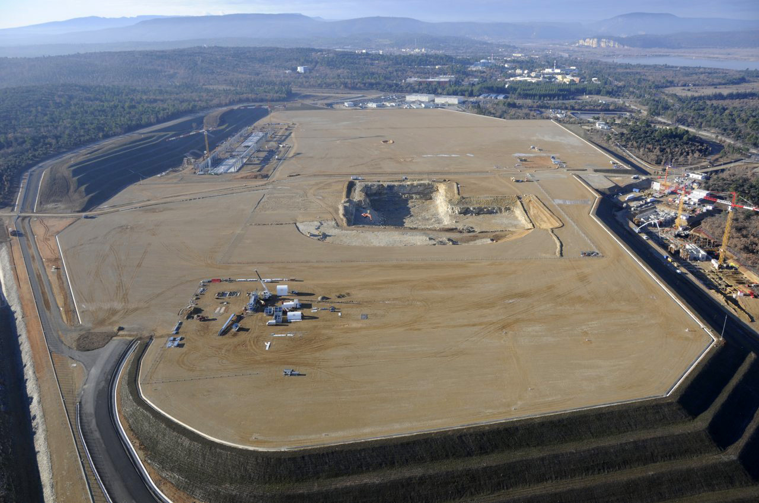

Aerial view of ITER construction site, Cadarache, France,  December 2010 © F4E

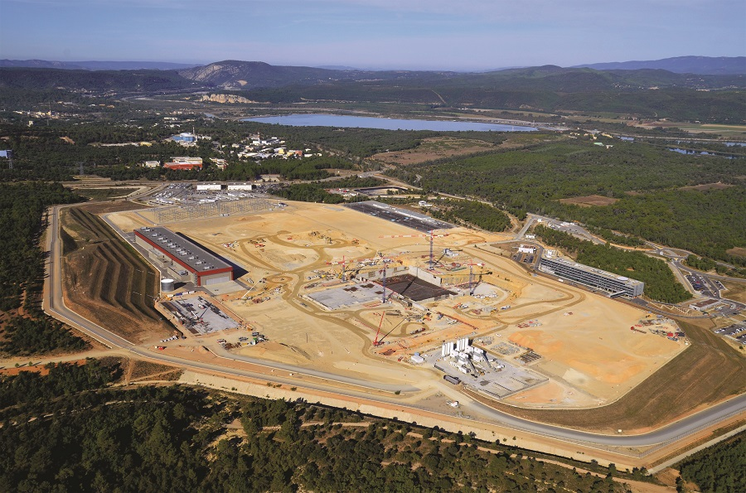

Aerial view of ITER construction site, Cadarache, France, Spring 2014 © F4E

To understand the significance of the progress it is important to go back in time. It all started in 2014 with the first pouring of concrete for the basemat slab of the Tokamak complex. Five years later, on 7 November, the VFR consortium (VINCI, Ferrovial, Razel-Bec) poured the final concrete at the Tokamak building, marking the successful completion of an important construction milestone. The civil engineering works began in 2010 with the excavation works posing a number of challenges to those involved. The tight timing, the degree of precision and the design, which needed to be revised, made things more complicated. This first-of-a-kind infrastructure for a fusion device was a new territory for all involved and needed to comply with the extremely strict standards set by France's Nuclear Safety Authority. For its construction approximately 10 types of concrete were developed to be used in different parts of the edifice. The building counts more than 80 000 embedded plates, anchored deep into the concrete, and positioned with accuracy to match the location of the ITER equipment that will be installed. Moreover, 18 of the 46 heavy doors weighing 70 t each have been installed, to keep inside the radiation resulting from the fusion reaction.

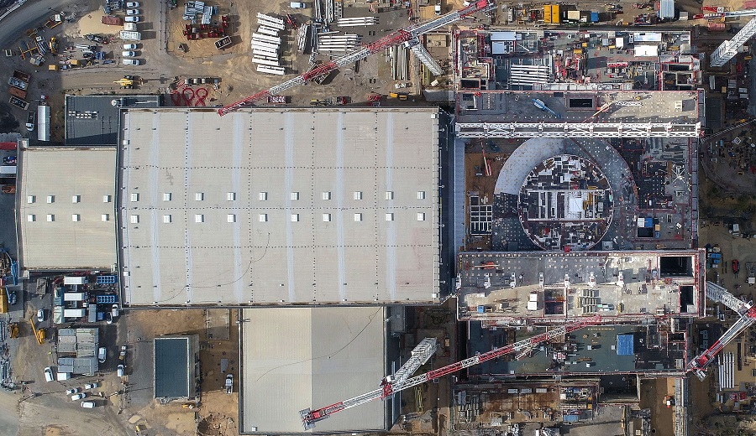

Pouring of last concrete at the Tokamak building. Aerial view of ITER Tokamak Complex, Cadarache, France, November 2019 © ITER Organization/EJF Riche

Some of the key people contributing to this achievement spoke to a group of journalists visiting the site who went there to witness the progress. "Europe is the party responsible for building ITER's infrastructure. Our close collaboration with VINCI, its partners, and more than 700 workers, has enabled us to finalise successfully this phase in compliance with the safety, security and quality requirements." said Laurent Schmieder (F4E), who oversees the team in charge of building construction and electrical systems for the ITER project.

For Bernard Bigot, Director-General of ITER Organization, this milestone should be seen in the broad scheme of things. "VINCI undertook to write a new chapter in one of the most ambitious and promising research experiments ever undertaken.  We warmly thank them for having been a highly capable, reliable partner sharing our objectives, standards and determination. The success of ITER will be theirs."

Jérôme Stubler, Chairman of VINCI Construction replied by acknowledging that "VINCI Construction and its partners Razel-Bec and Ferrovial are extremely proud of having carried out the ITER civil engineering works. This is an extraordinary human undertaking, posing a huge technical challenge, and we were constantly called on to innovate and expand our expertise. With ITER, we are humbly helping to implement one of the greatest and most ambitious energy projects of our time, designed to make electricity available without CO2 emissions [...]".

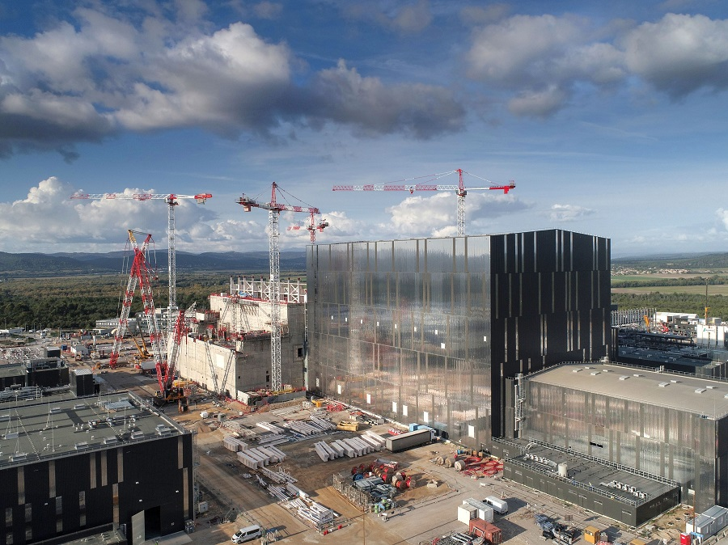

Aerial view of ITER Assembly Hall, Cadarache, France, October 2019 © ITER Organization/EJF Riche

On the site, one can feel the momentum building for the spectacular lifting operation of the Tokamak building's rooftop, planned to start end of this year. By December 2019 all steel structure columns and beams are expected to be installed and later in spring the assembly phase of the first components should begin. In the vast Assembly Hall, the coating of the floor with epoxy resin is in progress, while 98% of the cable connections and 80% of the piping are in place.

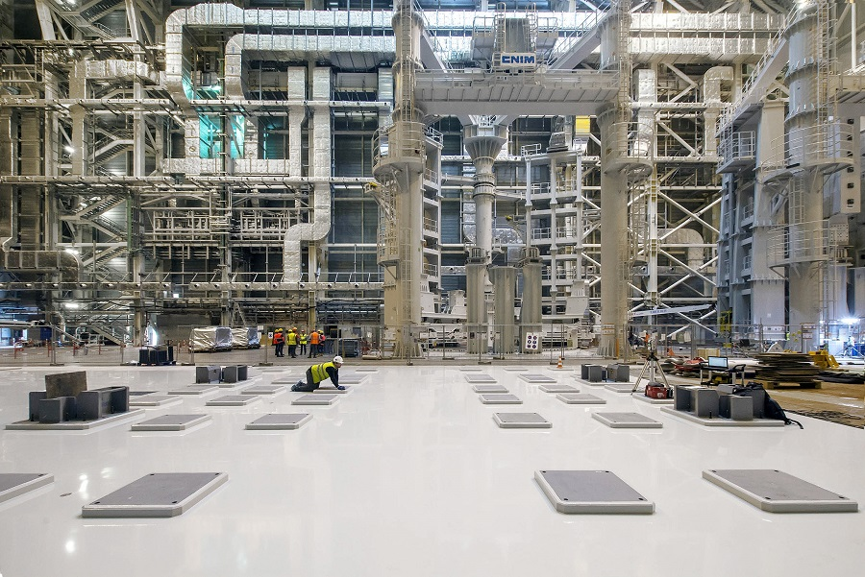

Inside the Assembly Hall, pipping and HVAC testing are performed whilst other contractors are coating its 6 500 m² floor with epoxy resin, Cadarache, France, October 2019 © ITER Organization

There has also been progress with the Power Supplies Distribution building, delivered by Ferrovial, which F4E handed over to ITER Organization on 21 October 2019. To put in simple terms, the powerhouse of the fusion experiment is ready. In this building the electrical supplies that will feed with current all ITER systems are stored, except for the magnets and the plasma heating devices which have a separate current supply. Romaric Darbour, F4E Deputy Programme Manager for Buildings, Infrastructure and Power Supplies, confirms the good news and explains that the full power supply will be distributed on the worksite during 2020 using a stepped approach on the basis of needs.

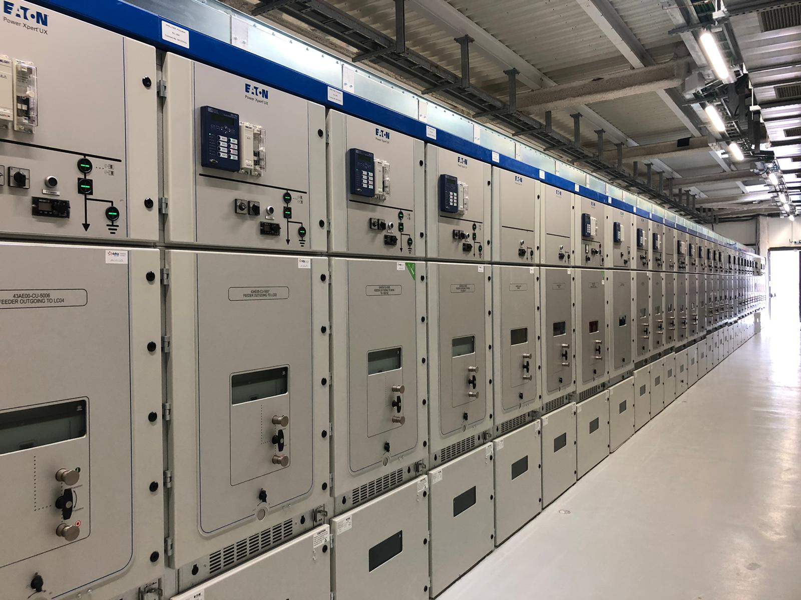

View of the equipment installed in the Power Supplies building. The works have been financed by F4E and carried out by Ferrovial, ITER construction site, Cadarache, France, October 2019 © F4E

Works in the galleries are also advancing rapidly. In this maze below the ground the piping and cabling of the project will cross cut the site. 95% of the deep underground networks are completed. Now it's the turn of the intermediate level, still below the ground, but qualifying as shallow trenches and buried networks.

According to ITER Organization, 70% of the construction required for the first plasma operations is finished. Europe and its contractors have accelerated the pace of delivering buildings and infrastructure as the date of 2025 is approaching. With more components expected to arrive as of next year, and assembly to kick off in spring, the construction site is set to become the technology workshop of the biggest scientific experiment in the field of energy.